

Title of the Paper: Desired to be within Fifteen Words Not Exceeding Two Lines (16 pt Type Size, Title Case, Bold)
First Middle Last/Surname¹, First Middle Last/Surname²*, First Middle Last/Surname³
^{1,2}Designation, Department Name, Organization or University Name, City, Country.
³Designation, Department Name, Organization or University Name, City, Country.
*Corresponding Author Email: …@....
(Received: 00.00.0000; Accepted: 00.00.0000)
Abstract
This document is a template for the International Journal of Technology, Health and Sustainability. The template defines the components of your paper (title, text, headings, etc.) in the required style. Abstract should be written in English (100 to 250 words; 10 pt, Italic). The abstract should be structured with brief descriptions of purpose, methods, results, and conclusions. Please be sure to emphasize original and important aspects of your research. Authors are advised to strictly adhere to this template for the smooth review and publication process of the submitted manuscript.
Keywords: Technology; Health and sustainability; Four to six keywords

INTRODUCTION (MAIN HEADING: 10 PT CAPITAL BOLD)
This template has been tailored for output on the A4 paper size. The template provides authors with most of the formatting specifications (including margins, column widths, line spacing, and type styles). The formatting specifications are built-in needed for preparing electronic versions of their papers. The body text is in 10 pt size.
The introduction generally provides the necessary background of the paper and a brief review of related literature. A clear statement of the objectives and novelty of the study should also be included.
MATERIALS AND METHODS (MAIN HEADING)
This section may contain several parts such as study area, materials, experimentation, data organization, methodology adopted, etc. based on the nature of research and presentation.
Use of Text Box for Figures (Sub-heading 1: 10 Pt, Title Case, Bold)
All figures, whether photographs, graphs, or diagrams, should be cited in the text as Fig. 1 where appropriate, and numbered sequentially with Arabic numerals. It is suggested to use a text box to insert a graphic or figure (Picture-as windows metafile or TIFF or JPEG or Bitmap files, with all fonts embedded). In an MSW document, this approach / method is more stable and easier to edit/move than directly inserting a picture. The frame of text box may have visible grey lines or non-visible lines.
A sample of text box for a figure or picture is provided hereunder in Fig. 1.
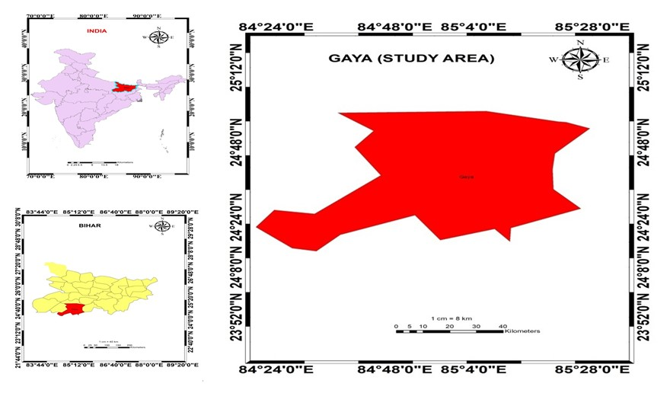Fig. 1: Example of a figure caption.
Use of Text Box for Tables (Sub-heading 1)
All the tables should be cited in the text as Table 1 where appropriate, and numbered sequentially with Arabic numerals. It is suggested to use a text box to insert a table (as editable format, NOT as image or picture). The frame of text box may have visible grey lines or non-visible lines.
Use the following table format (Table 1) in the manuscript.
Table 1: Example of a table caption.
LU Classes  and its Colour | Description
Built-up land /  Urban area (Red) | Settlements, industrial areas, commercial areas, rural areas, mining
Forest cover (Green) | Deciduous, scrub forest
Water body (Blue) | Rivers, ponds and lakes

Equations (Sub-heading 1)
Equations should be written using equation editor, and be formatted as shown below –
$User Accuracy=\frac{Diagonal value of row ×100}{Row total}$ (2)
RESULTS AND DISCUSSION (MAIN HEADING)
This section contains the results and their interpretation of the results in relation to the existing knowledge. A few examples of first sub-heading and second sub-heading are provided.
Data Analysis by Descriptive Statistics (Sub-heading 1: 10 Pt, Title Case, Bold)
Descriptive statistics provide a clear overview of the main features of a dataset without making predictions or inferences about a larger population.
The frequency distribution has organized the data into intervals to observe patterns and distributions. …………
Operating research models (Sub-heading 2: 10 pt, sentence case, italic)
These are mathematical and analytical methods used to answer complex questions and make informed decisions in various fields.
Comparison with the research model (Sub-heading 2)
The proposed research model has been compared with other reported models.
Data Analysis by Inferential Statistics (First Sub-heading: 10 Pt, Title Case, Bold)
Inferential statistics involves techniques that allow us to make predictions, test hypotheses, and draw conclusions about a population based on sample data.
CONCLUSION (MAIN HEADING)
State the conclusions in brief. Incorporation of the usefulness and limitations of the study, along with future recommendations enhance the quality of the paper.
Nomenclature (Sub-heading 1)
Symbol / Unit | Description / Full Form
µ | Kinematic viscocity
c_{p} | Specific heat capacity (J kg-1 K-1)
$L_{eq}$ | Equivalent noise level

Use the following format for nomenclature, if required.
ORCID iD 
Author Name Link
Author Name Link
Author Name Link
Acknowledgement (Sub-heading 1)
The authors are thankful to ……………… (name of person / organization / university) ………… for providing (nature of assistance) …….. for the study.
Grant Support Details (Sub-heading 1)
Please refer ‘Submission Guidelines’ of the journal.
Conflict of Interest (Sub-heading 1)
The statement is mandatory. Please refer ‘Submission Guidelines’ of the journal.
Life Science Reporting (Sub-heading 1)
Please refer ‘Submission Guidelines’ of the journal.
REFERENCES (MAIN HEADING)
All references should be listed at the end of the paper in 8 pt size using the following style/patterns. The DOI or weblink is optional.

- Foody, G.M. (1992) ‘On the compensation for chance agreement in image classification accuracy assessment’, Photogrammetric Engineering & Remote Sensing, 58(10), pp. 1459–1460.
- Saharan, S., Deswal, S. and Pal, M. (2024) ‘Air quality mapping and urban planning for sustainable urban ecology: a case study of Chandigarh, India’, Ecological Questions, 35(2), pp. 1–15. http://dx.doi.org/10.12775/EQ.2024
- Hu, X., Liu, W. and Huo, H. (2024) ‘An intelligent network traffic prediction method based on Butterworth filter and CNN–LSTM’, Computer Networks, 240, pp. 110172.
- WHO (2018) Priority eye diseases. World Health Organization. Available at: http://www.who.int/blindness/causes/priority/en/ (Accessed: 21 September 2020).
- International Federation of Robotics (IFR) (2024) World robotics 2024 report. Available at: https://ifr.org/ifr-press-releases/news/record-of-4-million-robots-working-in-factories-worldwide (Accessed: 31 July 2025).
- Deswal, S. and Deswal, A. (2017) A Basic Course in Environmental Studies. 3rd ed. New Delhi: Dhanpat Rai & Co. (P) Ltd.
- S. Jagannath v. Union of India (1997) AIR 1997 SC 811.

This template contain guidance text for composing and formatting manuscripts submitted to IJTHS. Please ensure that all template text is removed from your manuscript prior to submission to the journal.

